
ROYAL OAK PRIMARY SCHOOL FUN RUN – WEEK 2 UPDATE
Thanks to your generosity we have now raised over $5,300 which is fantastic ……. and this means the teachers are going to get slimed!! Please see below the timetable for each day
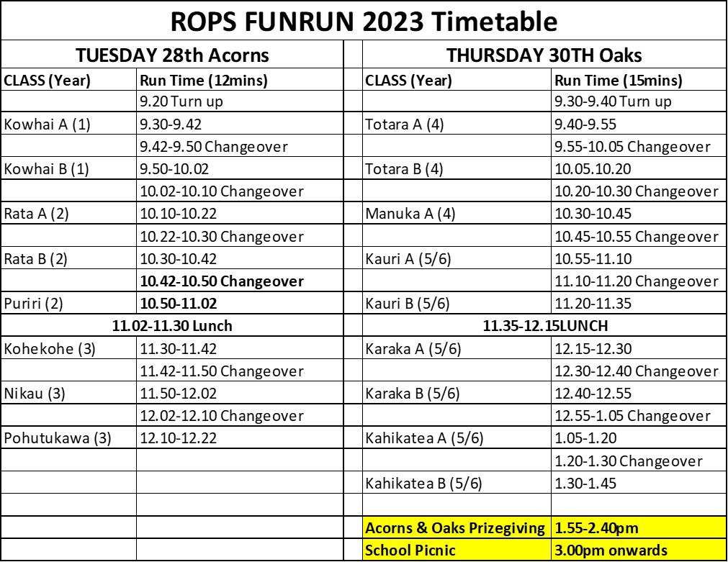
THE LATEST CLASS RANKINGS

Please share this link with as many friends and whanau as possible


